INTRODUCTION
This handout complements the Click & Learn The Eukaryotic Cell Cycle and Cancer ← LINK and is intended as a straightforward introduction to the cell cycle and how it relates to cancer. For a more comprehensive student handout, please see the in-depth version.

PROCEDURE
Follow the instructions as you proceed through the Click & Learn and answer the questions in the spaces below.
Launch the Interactive by clicking “Start Interactive” and Click on the “Background” tab on the right side (if it doesn’t appear already). Read the information and watch the videos.
- Why is cell division important for both single-celled and multicellular organisms?
For reproduction in unicellular (one-celled) organisms. For growth in multi-cellular organisms and to
replace dead/damaged cells.

- Why does cell division remain important to an adult organism even after it is fully developed?
To continually renew cells in specific areas. To heal wounds.

- Cells divide, differentiate, or die. What is differentiation?
When cells change structure to specialize in a function

- What is apoptosis? What is its purpose?
Cell Death. Apoptosis eliminates unnecessary cells during development and removes unhealthy/
damaged cells (before they have a change to divide)

- What are cell cycle regulators?
Molecular signals that may stimulate or halt cell division or initiate apoptosis.

- What happens if cell cycle regulators don’t function properly?
The organism may end up with too few or too many cells in certain places

Read the Overview of Cell Cycle Phases (if the overview is not already shown then click on the purple section labeled “Cell Cycle Phases”)
- Cells go through periods of growth and division. Cell division occurs during __M phase____.
The rest of the cell cycle is called interphase, list the 3 major events/ phases in the correct order of interphase. G1 → S → G2

- Click on each phase of the cell cycle and write details about what happens during each of the three phases labeled in the diagram below.
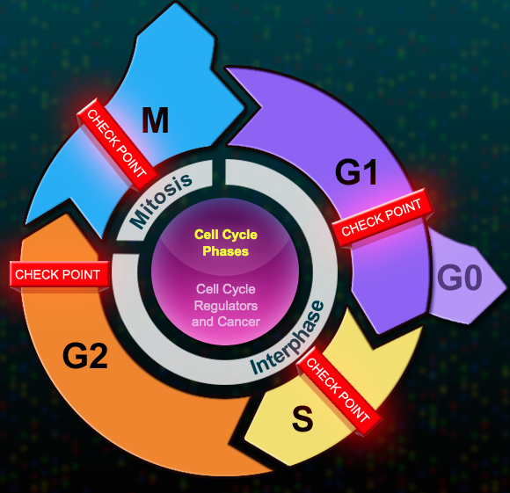

G₁: Cells increase in size and prepares for DNA replication (needs: No damage to DNA and sufficient
resources)

S: DNA is replicated ending in 2 complete sets of DNA. (needs: No errors during DNA replication)

G₂: Cells continue to grow. Prepare for mitosis (cell division) (Needs: no damage, errors, enough cell
components)

Click on the G0 section of the diagram and answer the following questions
- What is the G0 phase of the cell cycle?
A resting (non-dividing) stage

- Which factors determine whether a cell enters G0?
Stage of development, type of cell and resources available

- Can cells leave G0?
YES. Injury can cause cells to leave G0

Go back to the “Cell Cycle Phases” Overiew
- In general, what is the purpose of a checkpoint in the cell cycle?
Checkpoints are needed to make sure the cycle continues without errors/ damage and is done properly.

For the following questions, click on each checkpoint box (red) and read through it.
- What stimulates the cell to either Rest or Divide?
If the DNA is undamaged and enough resources are available for the cell to keep growing and divide, growth signals will stimulate the cell to proceed to S phase

- Create a checklist summary for each checkpoint:
  - G1 → No DNA damage and Sufficient resources
  - S → No errors during DNA replication
  - G2 → DNA w/o damage, Chromosome set complete, Enough cell components
  - M → All sister chromatids attached to mitotic spindles

